**History of Sign Language**

**Aristotle** was the first to have a claim recorded about the deaf. His theory was that people can only learn through hearing spoken language. Deaf people were therefore seen as being unable to learn or be educated at all.

Two of the largest deaf schools in America began educating the deaf in 1867 using only oral methods and encouraged all deaf schools to do the same.

It is now seen as the native communication and education method for deaf people. However, it wasn’t always this way.

Even though sign language became commonly used, supporters of the oralism method believed the deaf must learn spoken language to fully function in hearing society.

Probably the most devoted supporter of the oralism method was  
[Alexander Graham Bell](https://www.startasl.com/alexander-graham-bell) (yes, the man who invented the telephone)

**Definition of Sign language**

Sign language is classified as a natural language and in many countries it is legally recognized, and is taught to children with hearing impairments as a mother language, but it is a not universal language since as each vocally spoken language has its own sign language dialect.

Sign language is used by the community of Hearing Impaired people as the main means of communication.

A sign language is a language which uses manual communication and body language to convey meaning, as opposed to acoustically conveyed sound patterns. This can involve simultaneously combining hand shapes, orientation and movement of the hands, arms or body, and facial expressions to fluidly express a speaker's thoughts. Wherever communities of deaf people exist, sign languages have been developed.

**Properties of sign language**

Signing is not only used by the deaf, it is also used by people who can hear, but cannot physically speak.

Specifically, a sign language mimics the fundamental properties that are present in the spoken language, like the grammar and vocabulary and it is used to express complex as well as abstract meanings.

**Why we need to communicate with Hearing impairments people (problem)?**

Since the process of learning how to speak involves the use of auditory feedback,

People who are born with hearing impairments also face difficulties with speech even though they may have nothing physically wrong with their vocal system.

A great number of jobs require some form of communication with the public.

Being a teller at a bank, student, working the cash register at the mall, and working the ticket terminal at the airport are a few examples.

Jobs like these, while plentiful to most, are unavailable to members of the Deaf community since they are unable to communicate by sound.

**How to communicate with Hearing Impairments ?**

Communication between two people with hearing impairments involves the use of hands to describe the shape of something, or to describe actions. For example it is common (also to people with no hearing impairments) to express the action “go from this place to that place”, by pointing first to the source and “drawing” a line toward the destination.

Communication is augmented with the simultaneous use of facial expressions and body postures together with hands gestures to fully express in this language any meaning.

There are many situations where hand gestures are used in place of oral communication.

Babies may use simple gestures to express their needs before they learn to speak or adults in situations where speech is impossible or not appropriate.

**Why we need structured sign language?**

However, in contrast to these situations sign language is structured and has rules for composition and interpretation.

Exchange of information between a Hearing Impaired and a Normal Hearing person is difficult since the Normal Hearing person must be able to understand the sign language of the Hearing Impaired person.

**Whose responsibility to learn sign language?**

Because of the impairments that Hearing Impaired people have on hearing, the responsibility of learning the sign language falls on the Normal Hearing person or alternatively a third person that understands both oral and sign languages and would do the necessary translation from one language to the other.

How the translatation of signs works ?

A third alternative is to use a computer to act as a translator.

Ideally the computer system should watch Hearing Impaired person performing sign language and then translate it to speech for Normal Hearing person; to accommodate of a dialogue, the system should also listen the NH person speaking and should translate it into a form that the Hearing Impaired person could understand; that is either sign language or text.

There are several famous deaf people who have been the founders of many organizations, been pioneers in deaf education, written books, painted famous artworks, held world records in sports, acted on several well-known television shows, and even started newspapers…

**Famous Deaf-people that had made history**

The are many [famous deaf people](https://www.startasl.com/famous-deaf-people) who have made a name for the deaf throughout the history of sign language and proved that deaf people can

, in fact, make history

**Helen Keller** :- the most well-known deaf-blind person 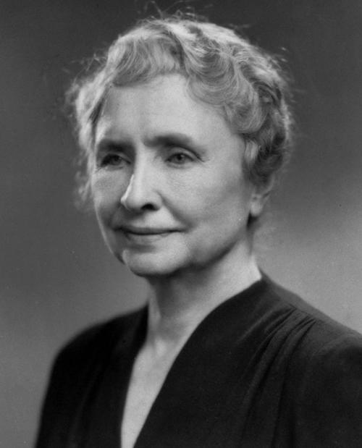

(She has taken the credit before Laura Bridgman).

While she wasn’t the first deaf-blind person to be educated,

Helen was the first one to graduate from college,

and she did it with honors.

**Alice Cogswell**:- Alice was the young deaf girl who inspired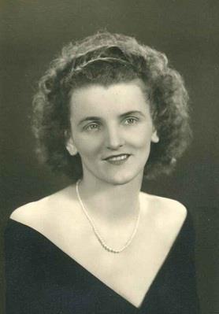

Thomas Hopkins Gallaudet to devote his life to

educating the deaf.

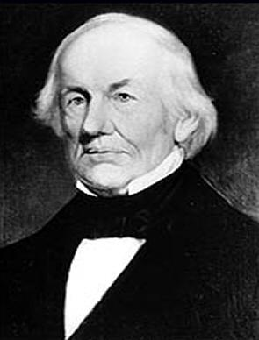

**Laurent Clerc**:-Met Gallaudet in Europe and

returned with him to the United States

and together, started the first school for the deaf in the US.

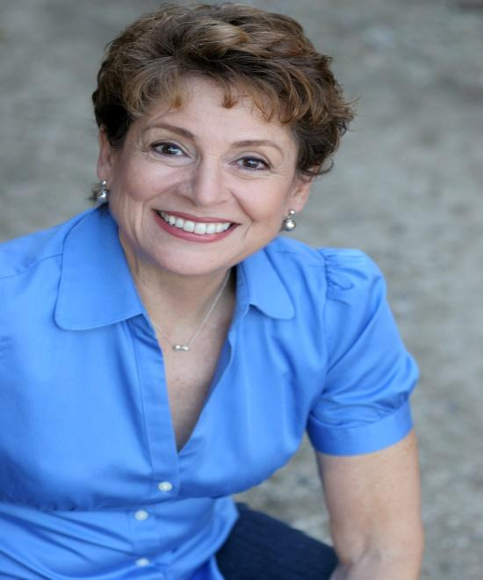

**Linda Bove** – The deaf actress who played

“Linda the Librarian” on Sesame Street,

as well as many other roles.

Marlee Matlin – The famous deaf actress

Who won an Academy Award for Best

Actress for her debut role in Children

Of a Lesser God at the age of twenty-one.

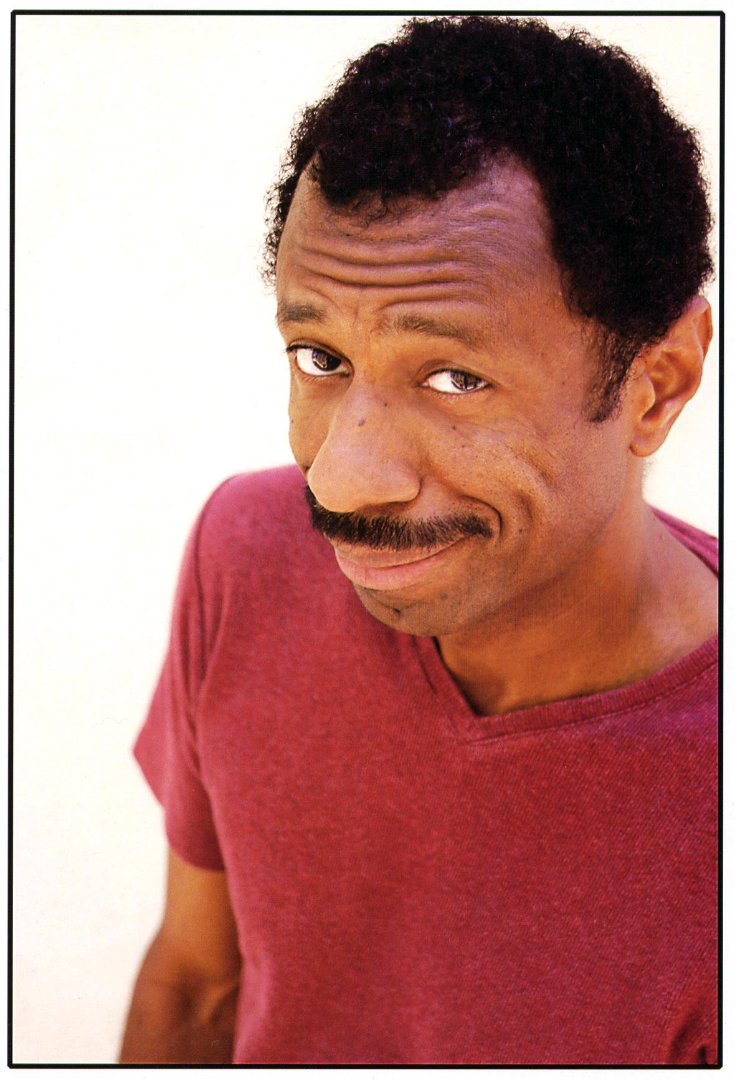

C.J. Jones – A very intelligent and talented

African-American deaf actor and comedian.

He has performed in many plays, TV shows,

and films.



Shoshannah Stern – Best known for playing

Holly Brodeen in Threat Matrix,

Bonnie Richmond in Jericho,

And Megan Graves on Weeds.

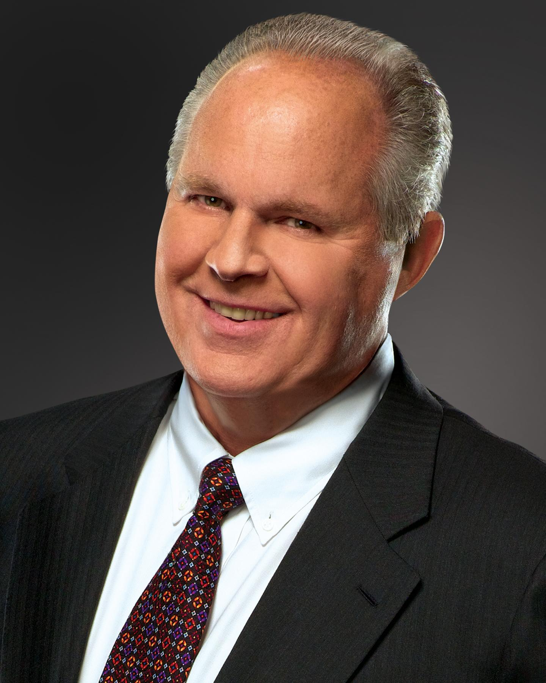

Rush Limbaugh – A talk show host who

Experienced sudden deafness.

Leslie Nielsen – Starred in many classics…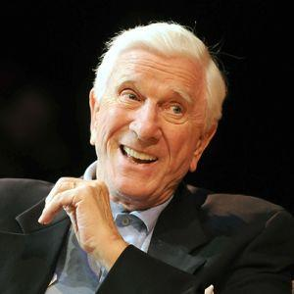

most notably Airplane.

James Lee Taylor III – Deaf Rapper 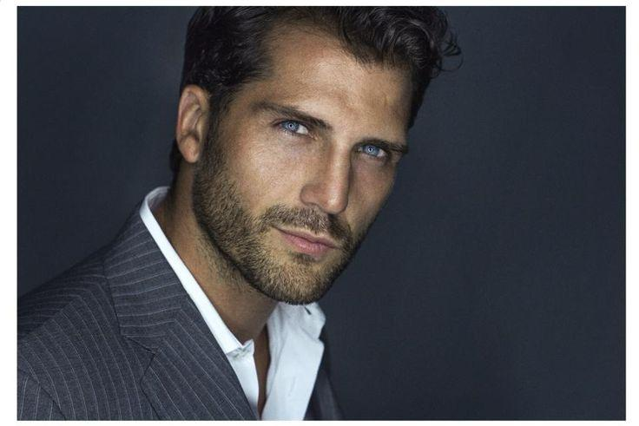

from the South Bronx on

NY Daily Newspaper

and City Limits Magazine.

His story has been told in

The book Train Go Sorry.

**Achievements to establish a successful communication between hearing**

**Impaired and normal people**

You have several great options for communicating with a deaf person. The most common methods will be lip-reading and sign language, but you might also communicate using a pen and paper, interpreter, or CART device. Whatever method you choose, there are some general rules of etiquette to help guide you. The most important thing is to be polite and attentive.

Method 1 : **Communicating Through Lip-Reading.**

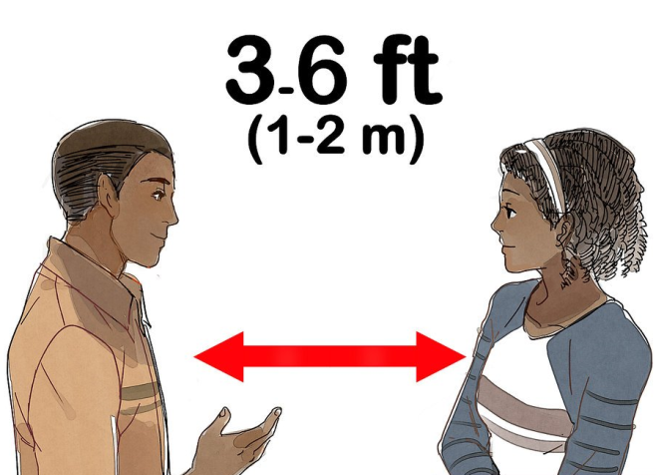

Method 2**: Using Sign Language.**

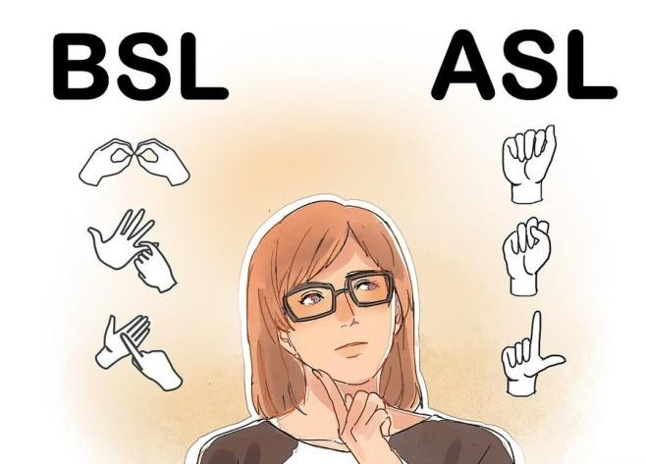

* **Determine your language.**
* **Study letter and numbers.**
* **Practice common phrases.**

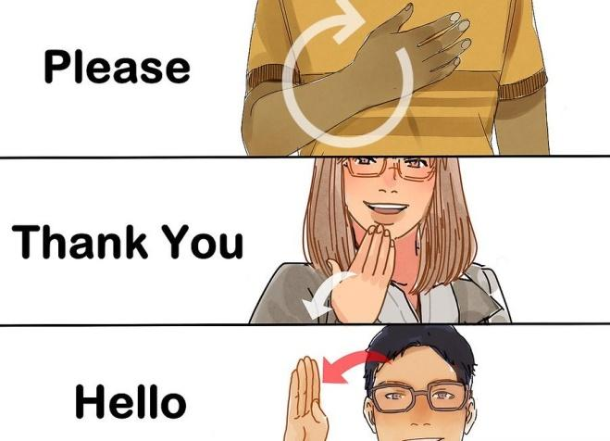

* **Improve your understanding of sign language.**
* **Confirm that the person speaks sign language.**

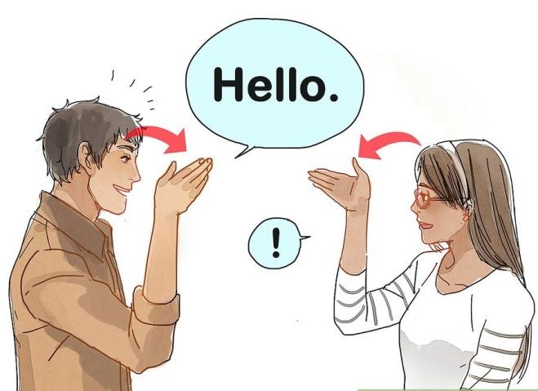

* **Face your hands and body toward them.**

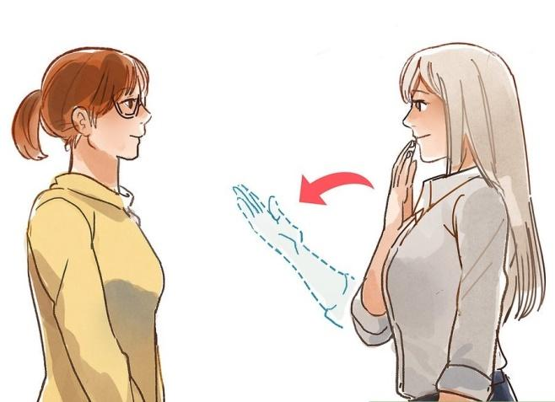

**Hearing aids** these are devices that help in hearing. There are several types of hearing aids; they come in a range of sizes, circuitries, and levels of power. They do not cure deafness, but amplify the sound that enters the ear so that the listener can hear things more clearly.

With all those efforts, but, as the authors say, the problem is far from being solved.

The research community has placed a great effort in developing a sign language recognition (SLR) system.

**Why the problem of communication still exist ?**

Most implementations rely on image processing, and, despite the current advances on matching algorithms, still exists a need for great processing power in order to support real-time recognition. Nevertheless, the research community has been focused on showing that it is possible to make SLR, but limiting their studies in terms of lexicon or relying on the usage of special gloves.

In what concerns the commercial aspect of teaching this form of communication, there are not many forms one can learn sign language. Nevertheless, specialized schools and videos exist, but are still limited.

**Improvements of methods for communicationg**

The Kinect device, introduced by Microsoft, was intended to revolutionize the gaming industry, with the removal of the joystick/controller from the game. Alongside this revolution, the Kinect sensor also started appearing in other research areas. One of this is the SLR area, where the research community started changing from traditional camera-based approaches to Kinect-based approaches.

**Used technologies**

Until recent years, most of the SLR systems were based on Hidden Markov Models, a statistical model in which the system to be modeled is assumed as a Markov process with hidden states.

The work of Starner is based on these models, where he uses a single camera for data acquisition and the signing is tracked with the assistance of solid color gloves. The prototype developed achieved a 97 percent accuracy while sing a forty word lexicon.

Recently, also due to the development on the machine learning and computer vision fields, Correia proposed two different algorithms for SLR:

1. a K-Nearest  Neighbor (KNN)

And

1. A Support Vector Machine (SVM).

**OUR SOLUTION**

**HEAR** is system that uses Microsoft Kinect device to build a translation system that translates signs from sign language to spoken language.

The main objective of the project is to develop desktop interactive application software for automatic translation of Arabic sign language into speech. This language translator should be able to translate one handed fingerspelling input of Arabic sign language Alphabets أ-ي and numbers 1-9 into spoken Arabic audio output.